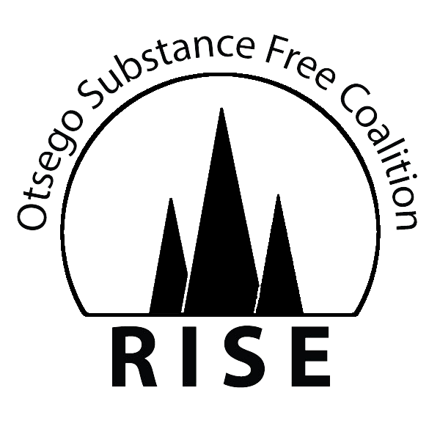
APPLICATION

NAME: ________________________________ SCHOOL: ______________________________________
ADDRESS: _____________________________ GRADE: ______________________________________
PHONE: ________________________________ E-MAIL: ______________________________________
Why are you interested in RISE Youth? ________________________________________________ ______
__________________________________________________________________________________________
__________________________________________________________________________________________
How can you benefit our group? _______________________________________________________________
__________________________________________________________________________________________
__________________________________________________________________________________________
What do you see as some of the specific issues facing teens today related to substance use? ____________________________________________________________________________ __
Do you agree to remain drug/alcohol/nicotine free? YES NO

Have you ever attended a RISE Youth Event? (i.e., RISE to the Occasion
or supported us by wearing our bracelets?) YES NO

Two School Faculty References (Name and Phone number)

_______________________________________ ________________________________________

By joining this group, I will maintain a drug and alcohol-free lifestyle

_______________________________ __________________
Signature Date

_______________________________ __________________
Parent Signature Date

Please return the completed form to: RISE: Otsego Substance Free Coalition
95 Livingston Blvd
Gaylord, MI 49735
or by email to: e.templeton@nwhealth.org
I give permission for my child, __________________________________, to join RISE: Otsego Substance Free Youth and to travel to RISE Youth activities when necessary. This permission is granted for up to four years from the date signed below. I may withdraw my permission by contacting Ellen Templeton in person or writing at the following address: 95 Livingston Blvd, Gaylord, MI 49735.
I understand my child may be traveling in personal cars driven by an advisor or volunteer adults. With my signature at the bottom, I release the RISE: Otsego Substance Free Coalition, and RISE adult advisors from any liability if my child is injured while on a RISE youth related trip as a result of the ordinary negligence of any employee, volunteer, officer or agent of the parties listed above. I also understand that I will receive a separate request for permission form for each occasion my child will be transported more than 45 miles outside of Otsego County.

By signing this permission form, I also give any of the adult volunteers, in the absence of a parent or guardian, permission to seek and approve medical treatment for my child while on a RISE related trip.

Signature of Parent or Guardian ___________________________________________ Date _____________
Printed name of Parent or Guardian __________________________________________________________
Insurance Company and Policy Number ______________________________________________________

My Child, _______________________, has permission to ride with another RISE Youth teen driver to RISE Youth meetings and/or events.
Parent Signature: ________________________________Date____________
Declined: __________________________________________________________________________________

My telephone number is (day) ____________________________________________
(evening) ___________________________________________
Address: _____________________________________________________________
Family email: _________________________________________________________
Child Image Release Form

New technology provides many more opportunities for students and their work to be showcased. RISE: Otsego Substance Free Youth need your permission to use any photograph, digital images, slides, video, or writing involving your child.
The use of photographs, voice, moving images, or writing images include but are not limited to RISE web site, Facebook, brochures, posters, theater ads or other forms of print electronic media.
Consent
I authorize RISE: Otsego Substance Free Coalition and RISE Youth to use photographs, digital images, slides, video, writings, or other similar media, including internet application in which ___________________________ appears.

I understand these images may be used for possible publication or shown for informational or educational purposes to a variety of audiences. I also understand that this Child Image Release Form will remain in effect until I revoke it in writing in a letter addressed to RISE: Otsego Substance Free Coalition, 95 Livingston Blvd, Gaylord, MI 49735, or until the materials are no longer needed by RISE.

__________________________________________ ____________________________
Signature of parent or guardian Date

__________________________________________
Printed name of parent or guardian
PLEASE COMPLETE, SIGN AND RETURN THIS FORM TO RISE: OTSEGO SUBSTANCE FREE YOUTH

